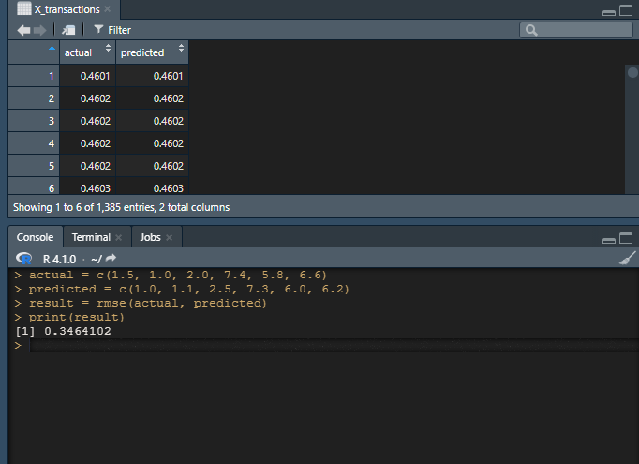

> actual = c(1.5, 1.0, 2.0, 7.4, 5.8, 6.6)

> predicted = c(1.0, 1.1, 2.5, 7.3, 6.0, 6.2)

> result = rmse(actual, predicted)

> print(result)

[1] 0.3464102

>